词频统计组件(LJWordFreq) 接口文档


http://ICTCLAS.nlpir.org/
@ICTCLAS张华平博士
2012-12
For the latest information about NLPIR, please visit Http://ICTCLAS.nlpir.org/

目录
词频统计组件(LJWordFreq) 接口文档 1
目录 2
0. 词频统计组件(又名LJWordFreq）简介 3
1．C＋＋接口 4
1.1 LJWF_Inits 4
1.2 LJWF_Exits 5
1.3 LJWF_WordFreqOutput 6
2 LJWordFreq运行环境 7
3 常见问题（FAQ） 8
Q1: LJWordFreq组件初始化老是失败 8
Q2: java获取xls中词频统计结果失败 8
4 作者简介 9

词频统计组件(又名LJWordFreq）简介
指词的频率,即词在一定的语料中出现的次数。词频的统计计算是计算语言学的重要内容之一。...词频统计的应用范围很广，它可以用于某部著作或某人的全部著作，从而揭示作家或著作的用词特点和语言风格。


访问http://ictclas.nlpir.org/(自然语言处理与信息检索共享平台)，您可以获取KeyExtract组件的最新版本，并欢迎您关注张华平博士的新浪微博 @ICTCLAS张华平博士 交流。
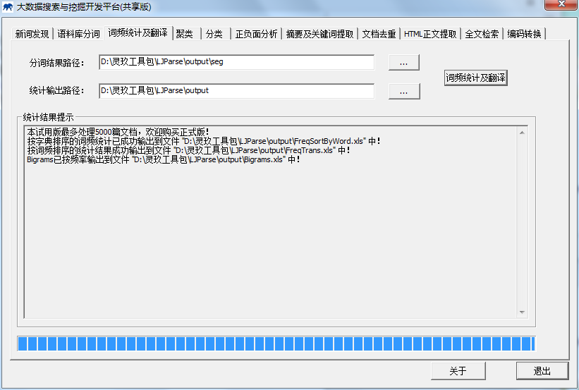

图1：词频统计组件演示

1．C＋＋接口

1.1 LJWF_Inits
Init the analyzer and prepare necessary data for LJWFaccording the configure file.
int LJWF_Inits(const char *path, int encode, const char*sLicenceCode=0);

Routine | Required Header
LJWF_Inits | < LJWordFreq.h>
Return Value
Return non 0 if init succeed. Otherwise return lower 0.
Parameters
sDataPath: Initial Directory Path, where Data directory stored. the default value is 0, it indicates the initial directory is current working directory path
int encoding: 默认为 GBK_CODE (GBK encoding), 也能是 UTF8_CODE (UTF8 encoding) 和 BIG5_CODE (BIG5 encoding).
char* sLicenceCode: license code, special use for some commercial users. Other users ignore the argument
Remarks
The LJWF_Inits function must be invoked before any operation with LJWordFreq. The whole system need call the function only once before starting LJWordFreq. When stopping the system and make no more operation, LJWF_Inits should be invoked to destroy all working buffer. Any operation will fail if init do not succeed.
LJWF_Inits fails mainly because of two reasons: 1) Required data is incompatible or missing 2) invalid parameters. Moreover, you could learn more from the log file 2014****.log in the current directory.
Example
int main(int argc, char* argv[])
{
if(LJWF_Inits("",0) < 0)
{
printf("初始化失败\n");
return -1;
}

if(!LJWF_WordFreqOutput("E:\\LJParse\\演示语料\\", "./"))
{
printf("词频统计失败\n");
return -1;
}
LJWF_Exits();
return 0;
}
Output

1.2 LJWF_Exits
Exit the program and free all resources and destroy all working buffer used in LJWordFreq.
void LJWF_Exits();
Routine | Required Header
LJWF_Exits | < LJWordFreq.h>
Return Value
NULL.
Parameters
none
Remarks
The LJWF_Exits function must be invoked while stopping the system and make no more operation. And call LJWF_Exits function to restart LJWordFreq.
Example
int main(int argc, char* argv[])
{
if(LJWF_Inits("",0) < 0)
{
printf("初始化失败\n");
return -1;
}

if(!LJWF_WordFreqOutput("E:\\LJParse\\演示语料\\", "./"))
{
printf("词频统计失败\n");
return -1;
}
LJWF_Exits();
return 0;
}
Output

1.3 LJWF_WordFreqOutput

bool LJWF_WordFreqOutput(const char* lpszFilename, char* DataPath);

Routine | Required Header
LJWF_WordFreqOutput | < LJWordFreq.h>
Return Value
Return true if succeed,or return false.
Parameters
lpszFilename: [IN] directory that process statistics of word frequency or not;
DataPath: [OUT] directory that dictionary file [Data].
Remarks
The dynamic library depends on NLPIR.dll or libNLPIR.so.and you will get the result from current directory ,the directory “/output” ,you wil find three .xls file
[Bigrams.xls] :[FreqSortByWord.xls]:[FreqTrans.xls]
So you will find the answer from this file .
The directory [/seg] include all file have been process by NLPIR_FileProcess;
Example
int main(int argc, char* argv[])
{
if(LJWF_Inits("",0) < 0)
{
printf("初始化失败\n");
return -1;
}

if(!LJWF_WordFreqOutput("E:\\LJParse\\演示语料\\", "./"))
{
printf("词频统计失败\n");
return -1;
}
LJWF_Exits();
return 0;
}
Output

2 LJWordFreq运行环境
1. 目前可以支持Windows环境，支持普通PC机器即可运行。
2. 支持GBK/UTF-8/BIG5

3 常见问题（FAQ）

Q1: LJWordFreq组件初始化老是失败
Answer:
请您保证NLPIR.user文件未过期，另外可参考“20***.err”文件查看错误信息

Q2: java获取xls中词频统计结果失败
Answer:
请您保证java的LJWF_WordFreqOutput接口的第一个参数的路径不是中文路径，Java中String默认是unicode编码格式，传入到该接口中可能无法访问该路径，另外可参考“20***.err”文件查看错误信息

4 作者简介

张华平 博士 副教授 硕导
北京理工大学计算机学院 院长助理
北京理工大学网络搜索挖掘与安全实验室 主任
地址：北京海淀区中关村南大街5号 100081
电话：+86-10-68918642
Email:kevinzhang@bit.edu.cn
MSN: pipy_zhang@msn.com;
网站: http://ictclas.nlpir.org (自然语言处理与信息检索共享平台)
博客:http://hi.baidu.com/drkevinzhang/
微博: @ICTCLAS张华平博士

Dr. Kevin Zhang (张华平，Zhang Hua-Ping)
Associate Professor, Graduate Supervisor
Dean Assistant, School of Computer
Director, Web Search,Mining and Security Lab.
Beijing Institute of Technology
Add: No.5, South St.,Zhongguancun,Haidian District,Beijing,P.R.C PC:100081
Tel: +86-10-68918642
Email:kevinzhang@bit.edu.cn
MSN: pipy_zhang@msn.com;
Website: http://ictclas.nlpir.org (Natural Language Processing and Information Retrieval Sharing Platform)
Blog:http://hi.baidu.com/drkevinzhang/
Twitter: @ICTCLAS张华平博士

