文本摘要组件(Summary) 接口文档


http://ICTCLAS.nlpir.org/
@ICTCLAS张华平博士
2012-12
For the latest information about NLPIR, please visit Http://ICTCLAS.nlpir.org/
Document Information

目录
文本摘要组件(Summary) 接口文档 1
目录 3
0. 文本摘要组件(又名Summary）简介 4
1．C＋＋接口 5
1.1 DS_Init 5
1.2 DS_Exit 7
1.3 DS_SingleDoc 8
1.4 DS_SingleDocE 9
1.5 DS_GetLastErrMsg 11
2 Summary运行环境 12
3 常见问题（FAQ） 13
Q1: Linux调用libSummary.so的时候，链接不上库 13
Q2: Summary组件初始化老是失败 13
4 作者简介 14

文本摘要组件(又名Summary）简介
所谓自动文摘就是利用计算机自动地从原始文献中提取文摘，文摘是全面准确地反映某一文献中心内容地简单连贯的短文。常用方法是自动摘要将文本作为句子的线性序列，将句子视为词的线性序列。
技术应用类型：
·自动提取给定文章的摘要信息
·自动计算文章中词的权重
·自动计算文章中句子的权重
·单篇文章的摘要自动提取
·大规模文档的摘要自动提取
·基于分类的摘要自动提取


访问http://ictclas.nlpir.org/(自然语言处理与信息检索共享平台)，您可以获取Summary组件的最新版本，并欢迎您关注张华平博士的新浪微博 @ICTCLAS张华平博士 交流。

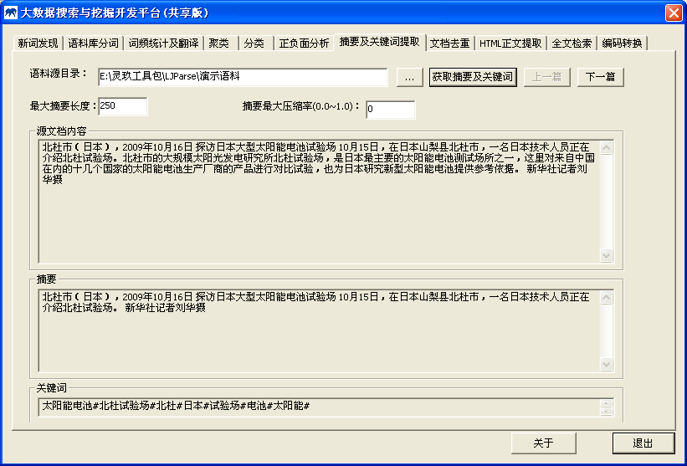
图1：文本摘要功能展示

1．C＋＋接口

1.1 DS_Init
Init the analyzer and prepare necessary data for Summary according the configure file.
bool DS_Init(const char *sPath=0,int nEncoding=GBK_CODE,const char *sLicenseCode=0);
Routine | Required Header
DS_Init | <LJSummary.h>
Return Value
Return true if init succeed. Otherwise return false.
Parameters
sPath: Initial Directory Path, where Data directory stored. the default value is 0, it indicates the initial directory is current working directory path
nEncoding: Encoding of input string, default is GBK_CODE (GBK encoding), and it can be set with UTF8_CODE (UTF8 encoding) and BIG5_CODE (BIG5 encoding).
const char* sLicenceCode: licence coding of input string,
Remarks
The DS_Init function must be invoked before any operation with Summary. The whole system need call the function only once before starting Summary. When stopping the system and make no more operation, DS_Exit should be invoked to destroy all working buffer. Any operation will fail if init do not succeed.
DS_Init fails mainly because of two reasons: 1) Required data is incompatible or missing 2) invalid parameters. Moreover, you could learn more from the log file 2014****.log in the current directory.
Example
int main(int argc,char* argv[])
{
if(!DS_Init("",GBK_CODE))
{
printf("sErrorMsg : %s \n", DS_GetLastErrMsg());
return -1;
}

vector<string> vsFileName;
fn_vScanFiles(argv[1], vsFileName,"txt");

string sOutput = "";

// 加载
printf("分析文章（Total %d）...\n",vsFileName.size());

for(int i=0; i<vsFileName.size(); i++) {
string sContent;
gfn_bReadFile(vsFileName[i].c_str(), sContent);
const char* sSummary = DS_SingleDoc(sContent.c_str());
printf("[1]本篇文章的摘要是SingleDoc：%s \n", sSummary);

char szSummary[1024] = {0};
const char* sRes = DS_SingleDocE(szSummary,sContent.c_str());
printf("[2]本篇文章的摘要是SingleDocE：%s \n, [3]%s\n", sRes,szSummary);
}
//const char* DS_SingleDoc(const char *sText, float fSumRate=0.00, int iSumLen=250);
DS_Exit();
}
Output

1.2 DS_Exit
Exit the program and free all resources and destroy all working buffer used in Summary.
void DS_Exit();
Routine | Required Header
DS_Exit | <LJSummary.h>
Return Value
none.
Parameters
none
Remarks
The DS_Exit function must be invoked while stopping the system and make no more operation. And call DS_Exit() function to restart Summary.
Example
int main(int argc,char* argv[])
{
if(!DS_Init("",GBK_CODE))
{
printf("sErrorMsg : %s \n", DS_GetLastErrMsg());
return -1;
}

vector<string> vsFileName;
fn_vScanFiles(argv[1], vsFileName,"txt");

string sOutput = "";

// 加载
printf("分析文章（Total %d）...\n",vsFileName.size());

for(int i=0; i<vsFileName.size(); i++) {
string sContent;
gfn_bReadFile(vsFileName[i].c_str(), sContent);
const char* sSummary = DS_SingleDoc(sContent.c_str());
printf("[1]本篇文章的摘要是SingleDoc：%s \n", sSummary);

char szSummary[1024] = {0};
const char* sRes = DS_SingleDocE(szSummary,sContent.c_str());
printf("[2]本篇文章的摘要是SingleDocE：%s \n, [3]%s\n", sRes,szSummary);
}
//const char* DS_SingleDoc(const char *sText, float fSumRate=0.00, int iSumLen=250);
DS_Exit();
}
Output

1.3 DS_SingleDoc

const char* DS_SingleDoc(const char *sText, float fSumRate=0.00, int iSumLen=250);

Routine | Required Header
CLUS_SetParameter | <LJSummary.h>
Return Value
Return summary string. Otherwise return NULL.
Parameters
sText: [IN] document content
fSumRate: [IN] the percentage of the document’s summary
iSumLen: [IN] document summary of the limited length
Remarks
Generation of single document summarization.
Example
int main(int argc,char* argv[])
{
if(!DS_Init("",GBK_CODE))
{
printf("sErrorMsg : %s \n", DS_GetLastErrMsg());
return -1;
}

vector<string> vsFileName;
fn_vScanFiles(argv[1], vsFileName,"txt");

string sOutput = "";

// 加载
printf("分析文章（Total %d）...\n",vsFileName.size());

for(int i=0; i<vsFileName.size(); i++) {
string sContent;
gfn_bReadFile(vsFileName[i].c_str(), sContent);
const char* sSummary = DS_SingleDoc(sContent.c_str());
printf("[1]本篇文章的摘要是SingleDoc：%s \n", sSummary);

char szSummary[1024] = {0};
const char* sRes = DS_SingleDocE(szSummary,sContent.c_str());
printf("[2]本篇文章的摘要是SingleDocE：%s \n, [3]%s\n", sRes,szSummary);
}
//const char* DS_SingleDoc(const char *sText, float fSumRate=0.00, int iSumLen=250);
DS_Exit();
}
Output

1.4 DS_SingleDocE

const char* DS_SingleDocE(char *sResult,const char *sText, float fSumRate=0.00, int iSumLen=250);
Routine | Required Header
DS_SingleDocE | <LJSummary.h>
Return Value
Return summary string. Otherwise return NULL.
Parameters
sResult: [OUT] document summary string
sText: [IN] document content
fSumRate: [IN] the percentage of the document’s summary
iSumLen: [IN] document summary of the limited length
Remarks
Generation of single document summarization.
Example
int main(int argc,char* argv[])
{
if(!DS_Init("",GBK_CODE))
{
printf("sErrorMsg : %s \n", DS_GetLastErrMsg());
return -1;
}

vector<string> vsFileName;
fn_vScanFiles(argv[1], vsFileName,"txt");

string sOutput = "";

// 加载
printf("分析文章（Total %d）...\n",vsFileName.size());

for(int i=0; i<vsFileName.size(); i++) {
string sContent;
gfn_bReadFile(vsFileName[i].c_str(), sContent);
const char* sSummary = DS_SingleDoc(sContent.c_str());
printf("[1]本篇文章的摘要是SingleDoc：%s \n", sSummary);

char szSummary[1024] = {0};
const char* sRes = DS_SingleDocE(szSummary,sContent.c_str());
printf("[2]本篇文章的摘要是SingleDocE：%s \n, [3]%s\n", sRes,szSummary);
}
//const char* DS_SingleDoc(const char *sText, float fSumRate=0.00, int iSumLen=250);
DS_Exit();
}
Output

1.5 DS_GetLastErrMsg
const char* DS_GetLastErrMsg();
Routine | Required Header
DS_GetLastErrMsg | <LJSummary.h>
Return Value
Return the lastest error msg.
Parameters
NULL
Remarks

Example
int main(int argc,char* argv[])
{
if(!DS_Init("",GBK_CODE))
{
printf("sErrorMsg : %s \n", DS_GetLastErrMsg());
return -1;
}

vector<string> vsFileName;
fn_vScanFiles(argv[1], vsFileName,"txt");

string sOutput = "";

// 加载
printf("分析文章（Total %d）...\n",vsFileName.size());

for(int i=0; i<vsFileName.size(); i++) {
string sContent;
gfn_bReadFile(vsFileName[i].c_str(), sContent);
const char* sSummary = DS_SingleDoc(sContent.c_str());
printf("[1]本篇文章的摘要是SingleDoc：%s \n", sSummary);

char szSummary[1024] = {0};
const char* sRes = DS_SingleDocE(szSummary,sContent.c_str());
printf("[2]本篇文章的摘要是SingleDocE：%s \n, [3]%s\n", sRes,szSummary);
}
//const char* DS_SingleDoc(const char *sText, float fSumRate=0.00, int iSumLen=250);
DS_Exit();
}
Output

2 Summary运行环境
1. 可以支持Windows、Linux、FreeBSD等多种环境，支持普通PC机器即可运行。
2. 支持GBK/UTF-8/BIG5

3 常见问题（FAQ）

Q1: Linux调用libSummary.so的时候，链接不上库
例如执行示例程序结果如下：
[root@localhost linux_c_sample]# ./test
./test: error while loading shared libraries: libSummary.so: cannot open shared object file: No such file or directory
Answer:
应当设置系统的LD_LIBRARY_PATH，即：export LD_LIBRARY_PATH=./
并且请保证在本目录也有libNLPIR.so

Q2: Summary组件初始化老是失败
Answer:
请您保证summary.user文件未过期，另外可参考“20***.err”文件查看错误信息

4 作者简介

张华平 博士 副教授 硕导
北京理工大学计算机学院 院长助理
北京理工大学网络搜索挖掘与安全实验室 主任
地址：北京海淀区中关村南大街5号 100081
电话：+86-10-68918642
Email:kevinzhang@bit.edu.cn
MSN: pipy_zhang@msn.com;
网站: http://ictclas.nlpir.org (自然语言处理与信息检索共享平台)
博客:http://hi.baidu.com/drkevinzhang/
微博: @ICTCLAS张华平博士

Dr. Kevin Zhang (张华平，Zhang Hua-Ping)
Associate Professor, Graduate Supervisor
Dean Assistant, School of Computer
Director, Web Search,Mining and Security Lab.
Beijing Institute of Technology
Add: No.5, South St.,Zhongguancun,Haidian District,Beijing,P.R.C PC:100081
Tel: +86-10-68918642
Email:kevinzhang@bit.edu.cn
MSN: pipy_zhang@msn.com;
Website: http://ictclas.nlpir.org (Natural Language Processing and Information Retrieval Sharing Platform)
Blog:http://hi.baidu.com/drkevinzhang/
Twitter: @ICTCLAS张华平博士

