文本聚类组件(Cluster) 接口文档


http://ICTCLAS.nlpir.org/
@ICTCLAS张华平博士
2012-12
For the latest information about NLPIR, please visit Http://ICTCLAS.nlpir.org/
Document Information

目录
文本聚类组件(Cluster) 接口文档 1
目录 3
0. 文本聚类组件(又名Cluster）简介 4
1．C＋＋接口 5
1.1 CLUS_Init 5
1.2 CLUS_Exit() 6
1.3 CLUS_SetParameter 7
1.4 CLUS_AddContent 8
1.5 CLUS_AddFile 10
1.6 CLUS_GetLatestResult 11
1.7 CLUS_CleanData 12
1.8 CLUS_GetLastErrMsg 13
2 Cluster运行环境 14
3 常见问题（FAQ） 15
Q1: Linux调用libLJCluster.so的时候，链接不上库 15
Q2: LJCluster系统初始化老是失败 15
4 作者简介 16

文本聚类组件(又名Cluster）简介
文本聚类（Text clustering）文档聚类主要是依据著名的聚类假设：同类的文档相似度较大，而不同类的文档相似度较小。作为一种无监督的机器学习方法，聚类由于不 需要训练过程，以及不需要预先对文档手工标注类别，因此具有一定的灵活性和较高的自动化处理能力，已经成为对文本信息进行有效地组织、摘要和导航的重要手 段，为越来越多的研究人员所关注。


访问http://ictclas.nlpir.org/(自然语言处理与信息检索共享平台)，您可以获取Cluster组件的最新版本，并欢迎您关注张华平博士的新浪微博 @ICTCLAS张华平博士 交流。

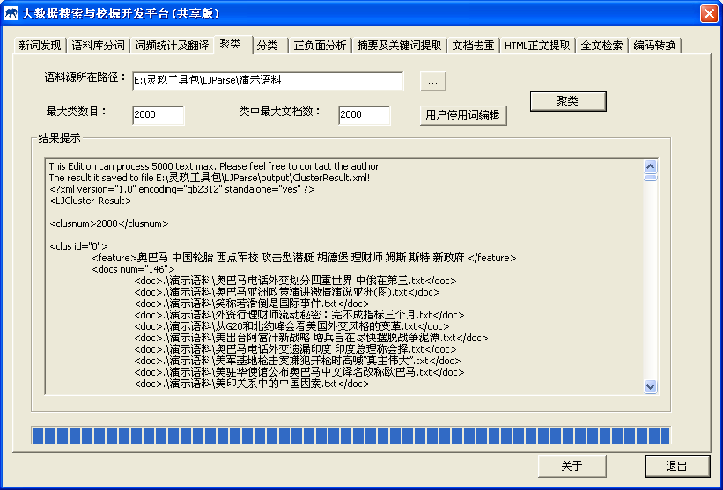
图1：文本聚类功能展示

1．C＋＋接口

1.1 CLUS_Init
Init the analyzer and prepare necessary data for Cluster according the configure file.
bool CLUS_Init(const char *sDefaultPath,const char *sLicenseCode=0);
Routine | Required Header
CLUS_Init | <LJCluster.h>
Return Value
Return true if init succeed. Otherwise return false.
Parameters
sDefaultPath: Initial Directory Path, where file userfilterword.txt and Data directory stored. the default value is 0, it indicates the initial directory is current working directory path
const char* sLicenceCode: licence coding of input string,
Remarks
The CLUS_Init function must be invoked before any operation with Cluster. The whole system need call the function only once before starting Cluster. When stopping the system and make no more operation, Cluster_Exit should be invoked to destroy all working buffer. Any operation will fail if init do not succeed.
CLUS_Init fails mainly because of two reasons: 1) Required data is incompatible or missing 2) userfilterword.txt file missing or invalid parameters. Moreover, you could learn more from the log file 2014****.log in the current directory.
Example
int main()
{
if(!CLUS_Init("./Data/Cluster"))
{
printf("分类模块初始化失败\n");
return -1;
}

CLUS_CleanData();
CLUS_SetParameter(3, 2);
char sText[100] = "中华人民共和国正式成立的时间是1949.10.1，代表人名正式当家作主的日子到了";
CLUS_AddContent(sText, sText);

string sResult;
CLUS_GetLatestResult("Result.xml");

gfn_bReadFile("Result.xml", sResult);
gfn_vReplaceSubstr(sResult, "\n", "\r\n");

printf("sResult : %s \n",sResult.c_str());
CLUS_Exit();
return 0;
}
Output

1.2 CLUS_Exit()
Exit the program and free all resources and destroy all working buffer used in Cluster.
void CLUS_Exit();
Routine | Required Header
CLUS_Exit | <LJCluster.h>
Return Value
none.
Parameters
none
Remarks
The CLUS_Exit function must be invoked while stopping the system and make no more operation. And call CLUS_Exit() function to restart Cluster.
Example
int main()
{
if(!CLUS_Init("./Data/Cluster"))
{
printf("分类模块初始化失败\n");
return -1;
}

CLUS_CleanData();
CLUS_SetParameter(3, 2);
char sText[100] = "中华人民共和国正式成立的时间是1949.10.1，代表人名正式当家作主的日子到了";
CLUS_AddContent(sText, sText);

string sResult;
CLUS_GetLatestResult("Result.xml");

gfn_bReadFile("Result.xml", sResult);
gfn_vReplaceSubstr(sResult, "\n", "\r\n");

printf("sResult : %s \n",sResult.c_str());
CLUS_Exit();
return 0;
}
Output

1.3 CLUS_SetParameter
Set the parameter.
bool CLUS_SetParameter(int nMaxClus, int nMaxDoc);
Routine | Required Header
CLUS_SetParameter | <LJCluster.h>
Return Value
Return true if init succeed. Otherwise return false.
Parameters
Int nMaxClus: Maximum number of classes which output
Int nMaxDoc: Maximum number of document which output inner each class
Remarks
This function must be invoked before other functions int the process,or
the default parameters were 2000;parameter is greater,more system memory,processing speed is slower, class and documents in the class have been sorted according to the importance and timeliness.
Example
int main()
{
if(!CLUS_Init("./Data/Cluster"))
{
printf("分类模块初始化失败\n");
return -1;
}

CLUS_CleanData();
CLUS_SetParameter(3, 2);
char sText[100] = "中华人民共和国正式成立的时间是1949.10.1，代表人名正式当家作主的日子到了";
CLUS_AddContent(sText, sText);

string sResult;
CLUS_GetLatestResult("Result.xml");

gfn_bReadFile("Result.xml", sResult);
gfn_vReplaceSubstr(sResult, "\n", "\r\n");

printf("sResult : %s \n",sResult.c_str());
CLUS_Exit();
return 0;
}
Output

1.4 CLUS_AddContent

Additional content.
bool CLUS_AddContent(const char *sText, const char* sSignature);
Routine | Required Header
CLUS_AddContent | <LJCluster.h>
Return Value
Return true if init succeed. Otherwise return false.
Parameters
sText: [IN] The Text content[The string which the last character is \0]
sSignature: [IN] The unique identifier [The string which the last character is \0]
Remarks
This function can be performed repeatedly before the result is printed
in the process
Example
int main()
{
if(!CLUS_Init("./Data/Cluster"))
{
printf("分类模块初始化失败\n");
return -1;
}

CLUS_CleanData();
CLUS_SetParameter(3, 2);
char sText[100] = "中华人民共和国正式成立的时间是1949.10.1，代表人名正式当家作主的日子到了";
CLUS_AddContent(sText, sText);

string sResult;
CLUS_GetLatestResult("Result.xml");

gfn_bReadFile("Result.xml", sResult);
gfn_vReplaceSubstr(sResult, "\n", "\r\n");

printf("sResult : %s \n",sResult.c_str());
CLUS_Exit();
return 0;
}
Output

1.5 CLUS_AddFile
bool CLUS_AddFile(const char *sFileName, const char* sSignature);
Routine | Required Header
CLUS_AddFile | <LJCluster.h>
Return Value
Return true if init succeed. Otherwise return false.
Parameters
sFileName: [IN] a full path of the file
sSignature: [IN] The unique identifier [The string which the last character is \0]
Remarks
This function can be performed repeatedly before the result is printed
in the process
Example
int main()
{
if(!CLUS_Init("./Data/Cluster"))
{
const char* sMsg = CLUS_GetLastErrMsg();
printf("分类模块初始化失败: %s\n",sMsg);
return -1;
}

CLUS_CleanData();
CLUS_SetParameter(3, 2);
char sText[100] = "中华人民共和国正式成立的时间是1949.10.1，代表人名正式当家作主的日子到了";
CLUS_AddFile("旅游业已成为西部地区的重要产业.txt", "旅游业");

string sResult;
CLUS_GetLatestResult("Result.xml");
gfn_bReadFile("Result.xml", sResult);
gfn_vReplaceSubstr(sResult, "\n", "\r\n");
printf("sResult : %s \n",sResult.c_str());
CLUS_Exit();
return 0;
}
Output

1.6 CLUS_GetLatestResult
Print the result.
bool CLUS_GetLatestResult(const char* sXmlFileName);

Routine | Required Header
CLUS_GetLatestResult | <LJCluster.h>
Return Value
Return true if init succeed. Otherwise return false.
Parameters
sXmlFileName: [OUT] XML file name;
Remarks
Output clustering content to XML file;
Example
int main()
{
if(!CLUS_Init("./Data/Cluster"))
{
printf("分类模块初始化失败\n");
return -1;
}

CLUS_CleanData();
CLUS_SetParameter(3, 2);
char sText[100] = "中华人民共和国正式成立的时间是1949.10.1，代表人名正式当家作主的日子到了";
CLUS_AddContent(sText, sText);

string sResult;
CLUS_GetLatestResult("Result.xml");
gfn_bReadFile("Result.xml", sResult);
gfn_vReplaceSubstr(sResult, "\n", "\r\n");
printf("sResult : %s \n",sResult.c_str());
CLUS_Exit();
return 0;
}
Output

1.7 CLUS_CleanData
Clean history data .
void CLUS_CleanData();

Routine | Required Header
CLUS_CleanData | <LJCluster.h>
Return Value
NULL.
Parameters
NULL
Remarks
Clean all history data
Example
int main()
{
if(!CLUS_Init("./Data/Cluster"))
{
printf("分类模块初始化失败\n");
return -1;
}

CLUS_CleanData();
CLUS_SetParameter(3, 2);
char sText[100] = "中华人民共和国正式成立的时间是1949.10.1，代表人名正式当家作主的日子到了";
CLUS_AddContent(sText, sText);

string sResult;
CLUS_GetLatestResult("Result.xml");
gfn_bReadFile("Result.xml", sResult);
gfn_vReplaceSubstr(sResult, "\n", "\r\n");
printf("sResult : %s \n",sResult.c_str());
CLUS_Exit();
return 0;
}
Output

1.8 CLUS_GetLastErrMsg

const char* CLUS_GetLastErrMsg();

Routine | Required Header
CLUS_GetLastErrMsg | <LJCluster.h>
Return Value
The lastest error information.
Parameters
NULL
Remarks
Get the latest error information.
Example
int main()
{
if(!CLUS_Init("./Data/Cluster"))
{
const char* sMsg = CLUS_GetLastErrMsg();
printf("分类模块初始化失败: %s\n",sMsg);
return -1;
}
CLUS_Exit();
return 0;
}
Output

2 Cluster运行环境
1. 可以支持Windows、Linux、FreeBSD等多种环境，支持普通PC机器即可运行。
2. 支持GBK/UTF-8/BIG5

3 常见问题（FAQ）

Q1: Linux调用libLJCluster.so的时候，链接不上库
例如执行示例程序结果如下：
[root@localhost linux_c_sample]# ./test
./test: error while loading shared libraries: libLJCluster.so: cannot open shared object file: No such file or directory
Answer:
应当设置系统的LD_LIBRARY_PATH，即：export LD_LIBRARY_PATH=./
并且请保证在本目录也有libNLPIR.so

Q2: LJCluster系统初始化老是失败
Answer:
请您保证在您的Data目录中包含有userfilterword.txt，并且cluster.user文件未过期，另外可参考“20***.err”文件查看错误信息

4 作者简介

张华平 博士 副教授 硕导
北京理工大学计算机学院 院长助理
北京理工大学网络搜索挖掘与安全实验室 主任
地址：北京海淀区中关村南大街5号 100081
电话：+86-10-68918642
Email:kevinzhang@bit.edu.cn
MSN: pipy_zhang@msn.com;
网站: http://ictclas.nlpir.org (自然语言处理与信息检索共享平台)
博客:http://hi.baidu.com/drkevinzhang/
微博: @ICTCLAS张华平博士

Dr. Kevin Zhang (张华平，Zhang Hua-Ping)
Associate Professor, Graduate Supervisor
Dean Assistant, School of Computer
Director, Web Search,Mining and Security Lab.
Beijing Institute of Technology
Add: No.5, South St.,Zhongguancun,Haidian District,Beijing,P.R.C PC:100081
Tel: +86-10-68918642
Email:kevinzhang@bit.edu.cn
MSN: pipy_zhang@msn.com;
Website: http://ictclas.nlpir.org (Natural Language Processing and Information Retrieval Sharing Platform)
Blog:http://hi.baidu.com/drkevinzhang/
Twitter: @ICTCLAS张华平博士

