Mycat+percona_cluster

MyCat 1.2 支持percona_cluster的集群模式，即多节点同时读写，牺牲了数据插入的性能而换来高可用性和读的性能，下面是测试报告。

软件版本:

Mycat: 1.2

Percona XtraDB Cluster: 5.6.15-25.3

Wsrep :25.3.r4034

系统:

服务器:华为Tecal RH2288 V2-8S

Cpu: Intel(R) Xeon(R) CPU E5-2620

processor : 24

Mem: 24G

Disk: Scsi Raid10

架构:



测试场景

1. 正常环境下三个数据库同时写入测试
2. 登录mycat

mysql -h10.20.38.68 -utest -ptest -P8066 TESTDB

1. 创建表

create table travelrecord (id bigint not null ,user_id varchar(100),traveldate DATETIME, fee decimal,days int);

C.1测试（400并发）

./test_stand_insert_perf.sh jdbc:mysql://10.20.38.68:8066/TESTDB test test 400 0-500M

结果

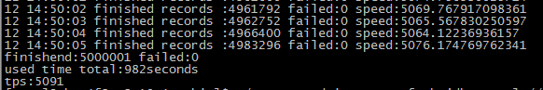

C.2 300并发

./test_stand_insert_perf.sh jdbc:mysql://10.20.38.68:8066/TESTDB test test 300 0-500M

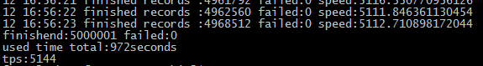

200并发

./test_stand_insert_perf.sh jdbc:mysql://10.20.38.68:8066/TESTDB test test 200 0-500M

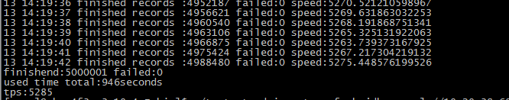

100并发

./test_stand_insert_perf.sh jdbc:mysql://10.20.38.68:8066/TESTDB test test 100 0-500M

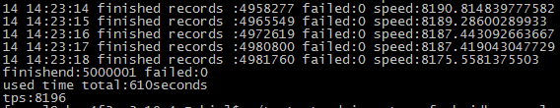

场景2，三个节点在高并发中宕掉一个节点

./test_stand_insert_perf.sh jdbc:mysql://10.20.38.68:8066/TESTDB test test 400 0-500M

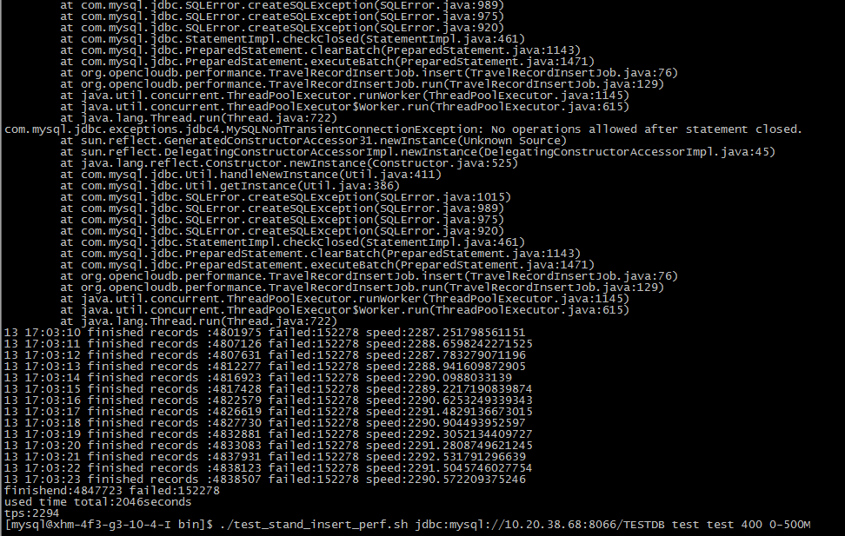

第二次测试

400并发



实际数据

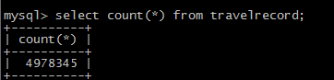

**存在部分数据没有写入的情况，此情况为检测节点失效过程中的时延导致，需要程序对SQL执行失败的数据进行处理，比如重新执行，或则写入文件中，事后分析和执行。**

查询测试

./test_stand_select_perf.sh jdbc:mysql://10.20.38.68:8066/TESTDB test test 100 1000 5000000

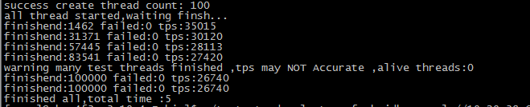

./test_stand_select_perf.sh jdbc:mysql://10.20.38.68:8066/TESTDB test test 200 1000 5000000

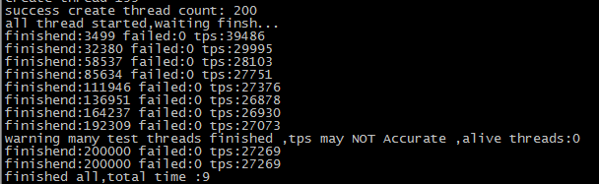

./test_stand_select_perf.sh jdbc:mysql://10.20.38.68:8066/TESTDB test test 300 1000 5000000

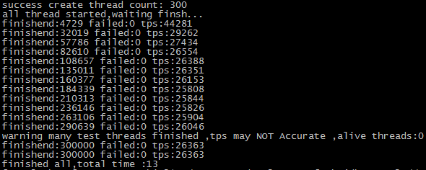

./test_stand_select_perf.sh jdbc:mysql://10.20.38.68:8066/TESTDB test test 400 1000 5000000

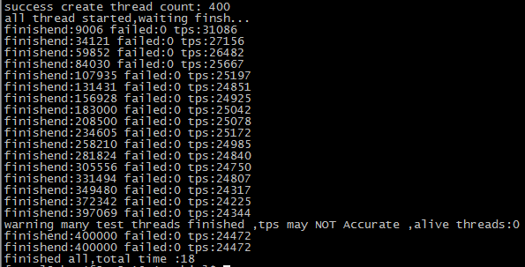

./test_stand_select_perf.sh jdbc:mysql://10.20.38.68:8066/TESTDB test test 500 1000 5000000

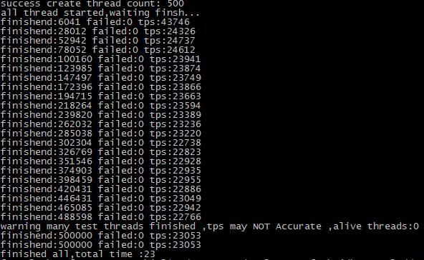

Mycat 配置

#cat schema.xml

<?xml version="1.0"?>

<!DOCTYPE mycat:schema SYSTEM "schema.dtd">

<mycat:schema xmlns:mycat="http://org.opencloudb/">

<schema name="TESTDB" checkSQLschema="true">

<table name="travelrecord" primaryKey="ID" dataNode="dn1,dn2,dn3" rule="mod-long" />

</schema>

<dataNode name="dn1" dataHost="localhost1" database="db1" />

<dataNode name="dn2" dataHost="localhost1" database="db2" />

<dataNode name="dn3" dataHost="localhost1" database="db3" />

<dataHost name="localhost1" maxCon="1000" minCon="10" balance="0" writeType="1"

dbType="mysql" dbDriver="native">

<heartbeat>select user()</heartbeat> #检测mysql状态,自己可以定制sql

<writeHost host="hostM1" url="192.168.1.1:3306" user="mycat" password="mycat"> </writeHost>

<writeHost host="hostM2" url="192.168.1.2:3306" user="mycat" password="mycat"> </writeHost>

<writeHost host="hostM3" url="192.168.1.3:3306" user="mycat" password="mycat"> </writeHost>

</dataHost>

</mycat:schema>

注意: writeType是设置多主的,0为当主宕掉后会到第二个节点写入(默认为0),1为同时向三个节点写入数据.

Mysql_cluster配置

cat my.cnf

[client]

socket= /usr/local/mysql/data/mysql.sock

[mysqld]

wait_timeout=28800

skip-host-cache

skip-name-resolve

#innodb

socket= /usr/local/mysql /data/mysql.sock

datadir= /usr/local/mysql /data

user=mysql

wsrep_provider= /usr/local/mysql/lib/libgalera_smm.so

basedir= /usr/local/mysql

#wsrep_cluster_address=gcomm://192.168.1.1,192.168.1.2,192.168.1.3

binlog_format=ROW

default_storage_engine=InnoDB

innodb_locks_unsafe_for_binlog=1

innodb_autoinc_lock_mode=2

##add new parameters

innodb_buffer_pool_size=15G

innodb_buffer_pool_instances=4

innodb_additional_mem_pool_size=20M

innodb_log_buffer_size=16M

innodb_flush_log_at_trx_commit=0

innodb_support_xa=0

innodb_file_per_table=1

innodb_data_file_path=ibdata1:100M:autoextend

innodb_read_io_threads=64

innodb_write_io_threads=64

innodb_io_capacity=5000

innodb_log_file_size=512M

innodb_thread_concurrency=0

innodb_file_format=Barracuda

innodb_flush_method=O_DIRECT

innodb_stats_on_metadata=0

#wsrep

###5.5.to update 5.6

#wsrep_provider_options="socket.checksum=1"

#log_bin_use_v1_row_events=1

#gtid_mode=0

#binlog_checksum=NONE

#read_only=ON

############################

wsrep_certify_nonPK=1

wsrep_debug=0

wsrep_convert_LOCK_to_trx=0

wsrep_max_ws_rows=131072

wsrep_max_ws_size=1073741824

wsrep_retry_autocommit=1

wsrep_auto_increment_control=1

wsrep_node_address=10.20.38.64

wsrep_node_name='node1'

#wsrep_sst_method=rsync

wsrep_sst_method=xtrabackup

wsrep_drupal_282555_workaround=0

wsrep_causal_reads=0

wsrep_slave_threads=48

max_connections=2000

wsrep_cluster_name=my_centos_cluster

#wsrep_debug=on

#wsrep_mysql_replication_bundle=200

wsrep_provider_options="socket.checksum = 1; pc.ignore_quorum = true; pc.weight=0; gcache.size=8G; evs.keepalive_period=PT3S; evs.inactive_check_period=PT10S; evs.suspect_timeout=PT30S; evs.inactive_timeout=PT1M; evs.consensus_timeout=PT1M; evs.send_window=1024; evs.user_send_window=512;"

wsrep_sst_auth="sstuser:s3cret"

配置和安装就不啰嗦,不懂的可以去百度或谷歌查询