MyCAT Installation Guide

MyCAT version1.2

QUICK START-INSTALLATION GUIDE(stank-alone mode)
The process of MyCAT runs on which server also runs a mysql process. Here we will introduce the installation process of MyCAT.

MyCAT is implemented in JDK1.7, so JRE1.7 or later version must be installed first for running it. You could download and install JDK or JRE from the URL below:
http://www.oracle.com/technetwork/java/javase/downloads/index.html
Get the newest version of MyCAT from https://github.com/MyCATApache

On Linux/Unix, it is suggested that to locate all files on the /usr/local/MyCAT, without any space character in directory names, like the following.
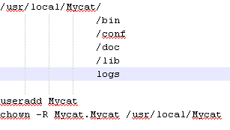
The following is the way to modify MyCat user's password (for reference)
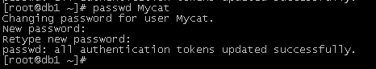

Following subdirectories below MyCAT are with the meanings as fllowing:
Directory named bin, stores shell scripts files for Linux and bat files for Windows. All the files provide service wrapped versions, and nowrapped ones. You can choose your way to use, and modify them as your purpose.
- In Windows, run mycat.bat in cmd window. You can config it to be a windows service. If some error occurs, run startup_nowrap.bat instead. Before running anything bat file, confirm java command is available.
- In Linux, execute commands as following.
chmod +x mycat
nohup sh mycat console &
In the wrap mode, it can be installed as a service to be started and stopped.
- mycat install (Optional command)
- mycat start
Directory named conf, stores configuration files. XML server.xml contains configurations for running and authorizing MyCAT server arguments. XML schema.xml contains configurations for logic database, table definations and sharding definations. XML rule.xml contains sharding rules, and arguments of sharding rules are stored as other files in this directory too. XML log4j.xml contains configurations for log, and you can modify it as your purpose.
NOTE that, the wrap mode procedure, whose JVM arguments are in conf/wrap.conf. You can modify it as your purpose. The URL http://wrapper.tanukisoftware.com/doc/english/properties.html is reference to modify.
There is an instance of wrap mode configuration:
NOTE: MyCAT requires JDK1.7. It would throw some exceptions with JDK1.6. You can specifiy the absolute path of JDK1.7 in the configuration file also.
THE FOLLOWING ARE SOME CONFIGRATIONS IN wrap.conf
wrapper.java.command=/usr/local/Mycat/jdk1.7.0/bin/java
# Java Additional Parameters
wrapper.java.additional.5=-XX:MaxDirectMemorySize=2G
wrapper.java.additional.6=-Dcom.sun.management.jmxremote
# Initial Java Heap Size (in MB)
wrapper.java.initmemory=2048
# Maximum Java Heap Size (in MB)
wrapper.java.maxmemory=2048
If there are not enough RAMs to startup, you could try to specify all memory params above, such 1G or 500M.
Log file is stored in logs/mycat.log, one log file per day. It could output more info, running as debug level, in order to troubleshoot.
You can run a Mysql server on the same machine which is running a MyCAT in QUICK START MODE.
Startup Mysql, and ensure it could be loged in and executed CRUD operations.
Connect to MySQL, create three databases as following:
CREATE database db1;
CREATE database db2;
CREATE database db3;
NOTE: if the mysql is for Linux, letter case insensitive is required, otherwise, table cannot be found by MyCAT probably. The config is as following:
lower_case_table_names = 1
To modify database connection arguments in MYCAT_HOME/conf/schema.xml.
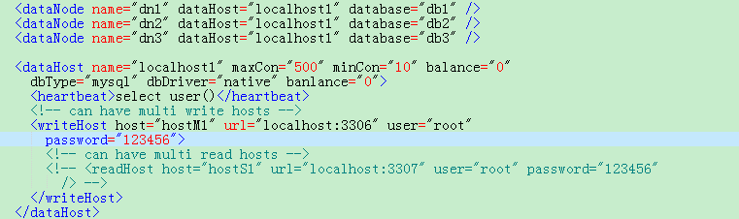
NOTE THAT, the arguments of location, user, password which belong to writeHost/readHost should compliance with your MySQL connection arguments.

修改完成后保存，进入到MYCAT_HOME/bin目录下，执行启动命令：startup.bat ，启动成功以后显示如下信息：
To save all modified configuration files, switch directory to MYCAT_HOME/bin, run command startup.bat in windows or mycat start in linux.
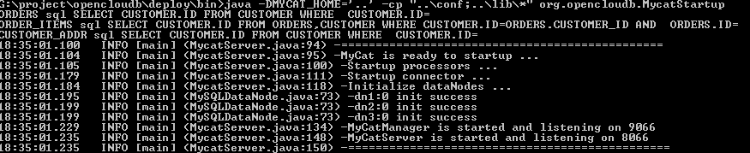
NOTE THAT, default port for data is 8066, and port for management is 9066.
You can also use GUI clients such as mysqlworkbench, navicat, and some other database clients implements in java. To specify port as 8066, and database name as TESTDB.
Run command following in command line, you can access MyCAT:
Mysql –utest –ptest –h 127.0.0.1 –P8066 –DTESTDB
All sql will be executed in this command line client process. If JDBC is to be used, the port should be changed to 8066.
NOTE: The username and authorization information are stored in conf/server.xml, meanwhile, the username and password of MySQL connected by MyCAT are stored in conf/schema.xml. They are the two indepency systems, and logical databases(schemas) and logical tables in MyCAT with respect to database and tables in MySQL are similar.

FOLLOWING IS A SIMPLE EXAMPLE
Table employee, is sharded according to the rule of sharding-by-infile, whose sharding field is sharding_id.
Create table employee by following SQL
create table employee (id int not null primary key,name varchar(100),sharding_id int not null);
Execute explain and check the SQL is to be sended which sharding nodes to execute:
explain create table employee (id int not null primary key,name varchar(100),sharding_id int not null);
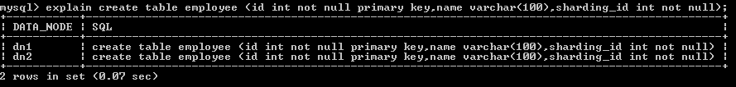
It is suggested that, check definition of employee in schema.xml and its sharding rule, and take a look that which data will be in dn1, and which will be in dn2.
温馨提示：explain可以用于任何正确的SQL上，其作用是告诉你，这条SQL会路由到哪些分片节点上执行，这对于诊断分片相关的问题很有帮助。另外，explain可以安全的执行多次，它仅仅是告诉你SQL的路由分片，而不会执行该SQL。
NOTE: command explain could be used for correct SQL, it tell you which node the sql will be routed to execute. It is useful to diagnose problems about sharding. Also, command explain could be safely executed multiple times, it tells you the sharding routees of SQL, but doesn’t execute it.
INSERT DATAS:
insert into employee(id,name,sharding_id) values(1,'leader us',10000);
insert into employee(id,name,sharding_id) values(2, 'me',10010);
insert into employee(id,name,sharding_id) values(3, 'mycat',10000);
insert into employee(id,name,sharding_id) values(4, 'mydog',10010);

Table company is sharded according to auto-sharding-long rule.
Create this table by following SQL:
create table company(id int not null primary key,name varchar(100));
INSERT DATAS：
insert into company(id,name) values(1,'hp');
insert into company(id,name) values(2,'ibm');
You will see the three records above are inserted into three sharding nodes, because company is global table. Execute explain to confirm it.
explain insert into company(id,name) values(1,'hp')
The information of three nodes are returned:
| DATA_NODE | SQL |
+-----------+---------------------------------------------+
| dn1 | insert into company(id,name) values(1,'hp') |
| dn2 | insert into company(id,name) values(1,'hp') |
| dn3 | insert into company(id,name) values(1,'hp') |
+-----------+---------------------------------------------+
Create table customer:
create customer: create table customer(id int not null primary key,name varchar(100),company_id int not null,sharding_id int not null);
INSERT DATAS:
insert into customer (id,name,company_id,sharding_id )values(1,'wang',1,10000); //stored in db1;
insert into customer (id,name,company_id,sharding_id )values(2,'xue',2,10010); //stored in db2;
insert into customer (id,name,company_id,sharding_id )values(3,'feng',3,10000); //stored in db1;
EXECUTE SELECT:
Select * from customer;
explain Select * from customer; #CONFIRM DATAS ARE STORED BY SHARDING

Create table orders, and insert datas:
create table orders (id int not null primary key ,customer_id int not null,sataus int ,note varchar(100) );
insert into orders(id,customer_id) values(1,1); //stored in db1 because customer table with id=1 stored in db1
insert into orders(id,customer_id) values(2,2); //stored in db2 because customer table with id=1 stored in db2
explain insert into orders(id,customer_id) values(2,2);
select customer.name ,orders.* from customer ,orders where customer.id=orders.customer_id;

Create table travelrecord and insert datas:
sravelrecord is stored by sharding rule of id range
create travelrecord: create table travelrecord (id bigint not null primary key,user_id varchar(100),traveldate DATE, fee decimal,days int);
insert into travelrecord (id,user_id,traveldate,fee,days) values(1,'wang','2014-01-05',510.5,3);#this id is stored in node 0
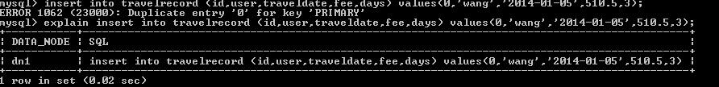

explain insert into travelrecord (id,user_id,traveldate,fee,days) values(7000001,'wang','2014-01-05',510.5,3); #this id is stored in node 1
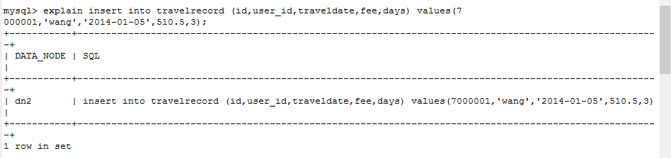

TO EXECUTE A CROSS-SHARDING JOIN
Hotnews are stored in dn1,dn2,dn3 by mod sharding.
create table hotnews(id int not null primary key ,title varchar(400) ,created_time datetime);
INSERT DATAS
insert into hotnews(id,title,created_time) values(1,'first',now()); #IN NODE1
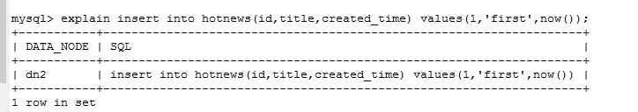
Meanwhile, id which value is 5, is stored in dn3, because of 5%3=2, and sharding nodes are counting from 0.
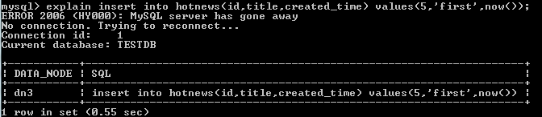

OTHER TABLES
Table goods
create table goods(id int not null primary key,name varchar(200),good_type tinyint,good_img_url varchar(200),good_created date,good_desc varchar(500), price double);
Wonderful Amazing World MyCAT, let’s explore it together!
QQ group: 106088787

